Highcliffe School Student Bulletin

Monday 11th – Friday 15th June 2007: Week A

Thought For The Week:
Don't count the days, make the days count (Muhammad Ali)

Year 7 & 8 Osmington Bay trip – November:
The second instalment of £33 is due on Friday 22nd June to the Finance Office.
If you have any problems please see Mr. Dean or Mr. Evans as soon as possible.

Year 10 Module 3 Exam Revision
Grade C/B
3.20-4.20pm in Ma3

- Tuesday 5th June Percentages, Fractions & Decimals

- Tuesday 19th June Standard Form, Factors & Multiples, Ratios

- Tuesday 26th June Measurement & Speed, Distance, Time

Year 10 GCSE Additional Science Exam Thursday 14th June 2007: This will take place lesson 4. You must line up outside the hall/performance hall at thend of lunch. Check you know where you are sitting, seating plans are displayed outside exams office. You will need to bring with you pens, pencils, rulers, rubbers, calculators and statements of entry. Remeber there are still revision classes on Monday, Tuesday and Wednesday check the Science noticboard for details and revision guides are still available from the Chemistry prep room for £3.
Good Luck!

Music lessons: Could any student who missed an instrument lesson to put their name, tutor group and instrument on a piece of paper and give it to Mrs Coomber or take it up to the Finance Office. This will enable them to get credits next term.


Vouchers: Please bring your Sainsbury's and Tesco vouchers to the Library. Ask your friends and relatives to donate any vouchers they have to Highcliffe as soon as possible. More vouchers, means we can buy extra resources for the school. Also don't forget Nestle's Box tops for books on the cereal packets, each one is worth 10p, so start cutting out those tokens!

Pure Funk - Are holding an audition meeting for people interested in auditioning for their Junior or Senior Dance Crew, training will begin in September for National Comps. Festivals and Promotional Events. The meeting is on Sunday 29th of July 2007. Posters up near the Dance Studio or PE, or see Miss Clark for more details.

Freestyle Dance Championship 2007 - Entry routine must be an original choreographed dance set (any style) lasting no longer than 2 minutes. For more information. see the poster on Dance Studio Door or see Miss Clark for details.

MUSIC NOTICES -
For those who want to be involved in performing in the summer concert:
Harmonious Funk Jazz band - Tuesday 3:30pm – 5.00pm
Shout - Wednesday 3:30pm - 4:30pm (Years 7 - 9)
Vocalis - Thursday 3:30pm - 4:30pm (Years 10 - 13)
Guitar Club - Friday lunchtimes 1.40pm - 2.10pm

BRAIN TEASER
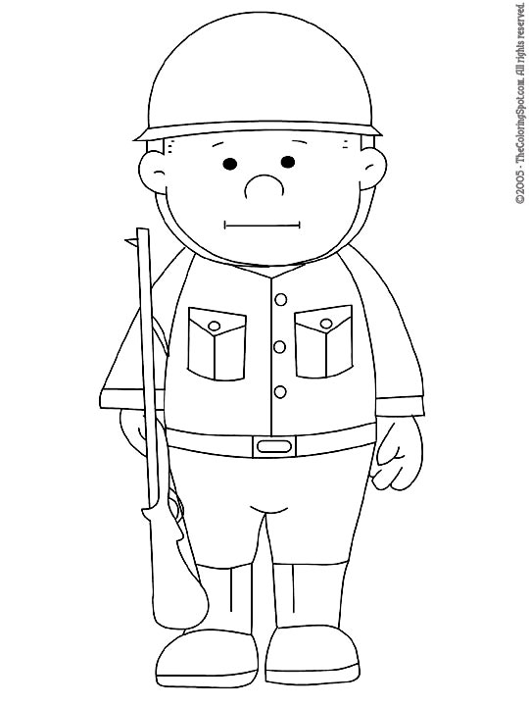
A group of soldiers were standing in the blistering sun facing due west. Their sergeant shouted at them:
Right turn!
About turn!
Left turn!
In which direction are they now facing?

Answers to be submitted in the Brainteaser box in Ma6 before Friday 13th July.

Good Luck!

AMAZING FACTS!

Did you know?

Some unusual phobias...can YOU say the words or can your TEACHER?

Hippopotomonstrosesquippedaliophobia
is the fear of long words.

Arachibutyrophobia
is a fear of peanut butter sticking to the roof of the mouth

P.E. FIXTURES/PRACTICES

11th June – 15th June 2007

 | LUNCHTIME | AFTER SCHOOL
Monday 21st |  | Year 8 cricket v Grange (H) (county cup)
Tuesday 22nd | Year 10 cricket | Year 8 rounders v Sturminster Newton (A)  Year 10 mixed rounders v Sturminster Newton (A)  Year 10 cricket v Arnewood (H)  Year 8 cricket v Arnewood (A)
Wednesday 23rd | Year 7 cricket | Athletics club  Year 7 rounders tournament @ Grange (2pm start)  Year 7 rounders v Shaftesbury (H)  Year 9 rounders v Shaftesbury (H)  Year 7 cricket v Arnewood (A)
Thursday 24th | Year 8 cricket | Friendly Athletics comp – Years 7 & 8 @ Grange  Years 9 & 10 rounders v Ballard (Venue to be confirmed)
Friday25th | Year 9 cricket

